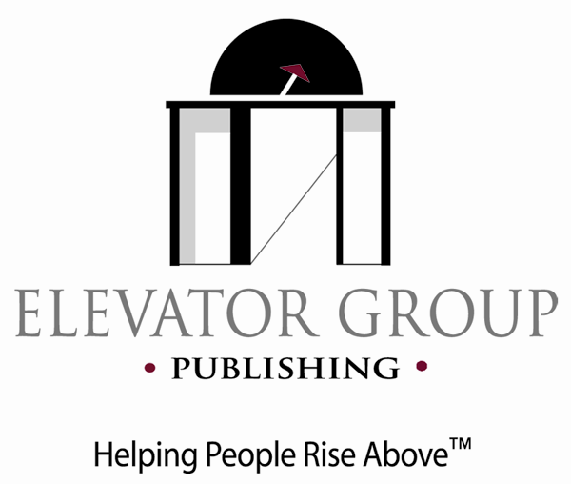
PO Box 207, Paoli, Pennsylvania 19301 info@TheElevatorGroup.com 610-296-4966
www.TheElevatorGroup.com

Contact: Sheilah Vance. svance@TheElevatorGroup.com 610-296-4966

Graduating Wellesley College student’s book, A Student’s Guide to Being Happy in Argentina named Finalist, General Non-Fiction, 2010 Next Generation Indie Book Awards

June 2, 2010--Paoli, PA—Paoli native Hope Lewis is not just happy that she graduted from Wellesley College on May 28. She’s also happy that her first book, A Student’s Guide to Being Happy in Argentina, was just named a Finalist in the General Non-Fiction, 2010 Next Generation Indie Book Awards.
The Next Generation Indie Book awards are open to all independent book publishers and authors worldwide. Awardees were honored at a reception at the Plaza Hotel in New York City during Book Expo America on May 25.
“I’m so happy that the Indie Book Awards have recognized that my book is unique and high quality,” said Hope, who did a study abroad in Buenos Aires, Argentina in her junior year. “I wrote this book because there really was nothing out there that addressed the nuts and bolts of what students really needed to know to be happy studying in and navigating Argentina. I’m glad that the judges saw that my book will be a great help to any student who is planning a study abroad in Argentina.”
A Student's Guide to Being Happy in Argentina addresses such issues of how to successfully handle the actual university classes, to getting along with the other students and your host family, to the ever popular bars, restaurants and other places to hang out. The book tells it like it is from the student's perspective. There's also a chapter called, "For the Parents", written by Hope's Mom after her visit, so students can help their parents be happy on the visits that they inevitably make to check up on their children.
The book also provides a unique and comprehensive guide to Argentina’s all-important soccer teams, gives the student’s perspective on sites to see and how to get there for Argentina and surrounding South American countries, and addresses what it’s like to be a minority in Argentina.
At Wellesley, Hope majored in Spanish and has taken numerous courses in Latin American studies. She has also worked for Social Accountability International, an international human rights organization, in New York City; has taught English to students in rural Nicaragua and to Spanish-speaking adults in Boston. A 2006 graduate of Conestoga High School in Berywn, PA, Hope is a native of Paoli, PA and is planning to enter the Peace Corps.
For more information about A Student’s Guide to Being Happy in Argentina, Trade Paperback ISBN 978-0-9786854-8-5; 90 pp.; $15.95, see www.TheElevatorGroup.com.

###

